Submission Portal User Guide
Version of 13 May 2014

Contents
User Experience 3
Submission Search 3
Refinement Panel 3
Search Result 4
Submission Screen 5
My Submissions Screen 7
Registration 7

User Experience

Dual function

The submission portal not only provides public access to submissions by Parties for consideration by the main bodies under the Convention and the Kyoto Protocol and the ability to retrieve them via submission search, it also enables Parties with access rights to directly upload their submissions via the submission screen and make them available on the portal in real time.

Submission Search

Submission search helps users find submissions and calls they are interested in. The following image is a screenshot of the submission search. The screen contains two parts presented in columns. The first part is the refinement panel which is displayed on the left side column. The second part shows the results panel, where all calls and related submissions will be displayed.

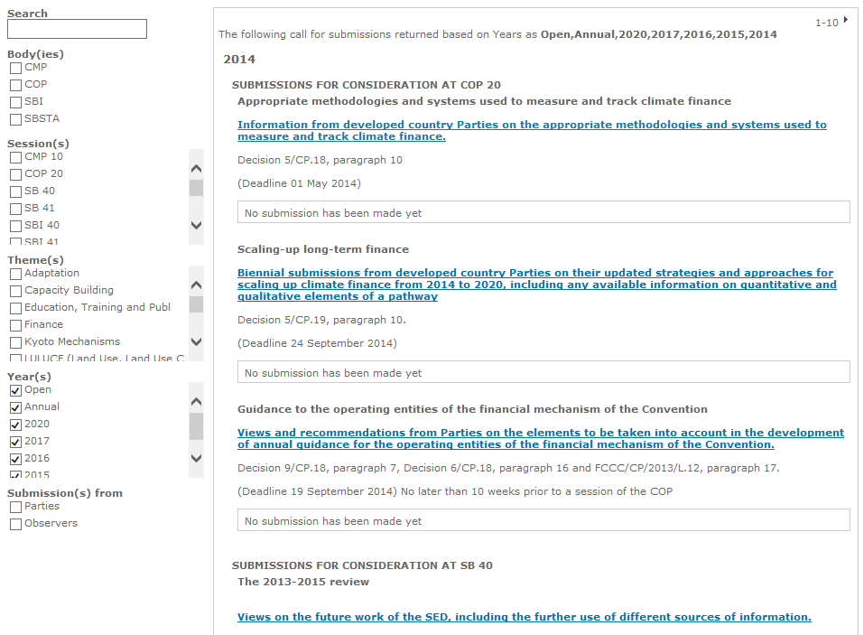

Refinement Panel

- Search: Allows users to search with keywords. This will be searched within the submission title, issue and mandate.
- Bodies: Allows user to filter call for submissions by bodies
- Sessions: Allows user to filter call for submissions by sessions
- Themes: Allows user to filter call for submissions by themes
- Years: Allows user to filter call for submissions by year
- Submissions from: Allows user to filter call for submissions by parties and observers

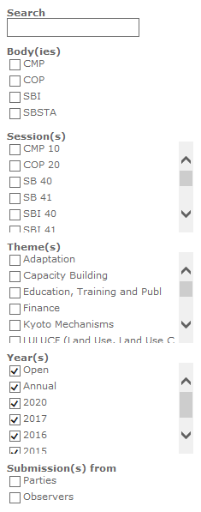

Search Result

- Highlight section: Displayed on top of the search result. It states which filter criteria have been applied for the result.
- Paging section: Displayed on the top right and bottom right corner. It allows user to navigate between pages.
- Year Grouping Section: Results are grouped by year first.
- Session Grouping Section: After year grouping results get sorted by sessions
- Call for Submission Detail Section: Call for Submissions are being listed within session grouping and displays the following information about the call for submissions; Submission Title, Issue, Mandate, and Deadline.
- Submitted Document Section: Submitted documents are displayed by chronological order of submission with the following information; Party, Date of submission and document link.

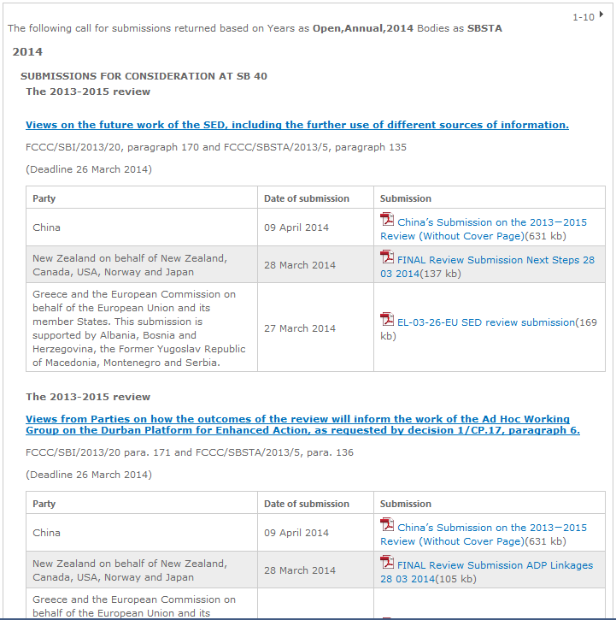

Submission Screen

This page requires an authentication. Only Party users with access rights can navigate to this screen from the submission search page. If you would like to access to this page please follow registration steps to register. On the search page clicking the title of the call for submission will take the user to the submission screen presented below.

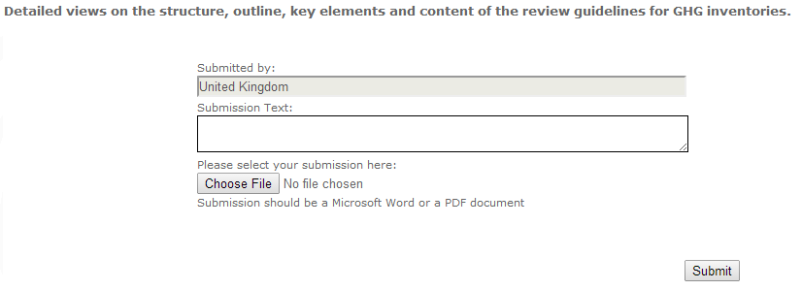

The name of the Party submitting the document appears automatically. The field “submission text” allows user to enter additional information on the document to be uploaded, as appropriate. In particular, if the submission is done on behalf of a group of Parties, this can be indicated in this field.

Clicking on “Choose file” will allow user to browse their computer and select the file to upload. To protect submission documents from unauthorized changes, please upload them as pdf documents or make the word documents as read only Clicking on the submit button will store these inputs in the system. The submission will appear in the submission search screen after a few minutes of processing.

My Submissions Screen
After the submission, user will be redirected to My Submissions screen where they can track their submission statuses. This screen can be accessed via My Work >> My Submissions menu as well.
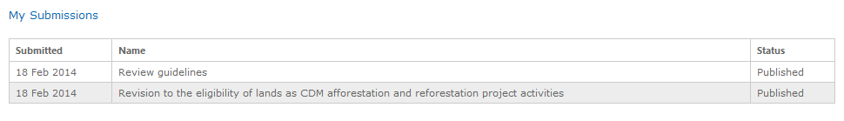

Registration

Please send an email to submission-info@unfccc.int with the following form supplied.

http://unfccc.int/documentation/submissions_from_parties/items/5900.php
Your request will be addressed in approximately1-2 working days.

